**TRIBHUVAN UNIVERSITY**

**INSTITUTE OF ENGINEERING**   
**Advanced College of Engineering and Management**

Department Of Computer and Electronics Engineering



**Report On**

Instrumentation-II Case Study

**Visit Undertaken At**

**Divine Winery Pvt. Ltd**

Nagarjun-1, Kathmandu

**Submitted By: - Submitted To: -**

Aashish Pokharel (ACE077BCT001) Dr. Er. Rakshya Dangol

Aashutosh Joshi (ACE077BCT002) Department Of Computer

Ashwani Kr. Chaudhary (ACE077BCT020) & Electronics Engineering

Ayush Acharya (ACE077BCT021)

Ayush Ratna Tamrakar (ACE077BCT022)

**ABSTRACT**

This report describes overall process of wine production from its raw materials. In the content of engineering, the context of instrumentation-II is very essential in the field of electronics engineer to overcome the design issues. The facilities provided by the college to perform a task in classes and labs are not adequate as they are insufficient. Therefore, we have been asked to conduct a case study on a production industry related to our field and view how the actual design’s principle are in practice.

This report represents presents an overview of the practical applications of electronics in Canary Beverage Pvt. Ltd. There is nothing such as perfect in real world. Thus, we are proposing some modification in the plant to improve its production capacity efficiently.

**TABLE OF CONTENTS**

1. **Acknowledgement**

**2. Introduction**

2.1. About Organization

2.2. Main Ingredient for Wine

2.3. Production

**3. Objectives**

**4. Wine Manufacturing Process**

4.1. Harvest

## 4.2. Crushing and Pressing

## 4.3. Fermentation

## 4.4. Clarification

## 4.5. Aging and Bottling

**5. Investment**

5.1. Raw Materials

5.2. Machineries

5.3. Production Costs

5.4. Marketing

**6. Block Diagram**

**7. Discussion and Conclusion**

**8. Photo Gallery**

**9. References**

**ACKNOWLEDGEMENT**

Learning is not only based on books and text activities. Especially, in engineering, where innovation and technical knowledge are appreciated, learning by practical applications is more fruitful than learning in isolated surrounding. It exposes one to real time working environment. Our learning process was made easier by various personalities. With the effort of various teaching and non-teaching staffs, our case study was successful, so we would like to express them our heart full acknowledgement. Thus we consider it as our privilege to express through this study a few words of gratitude and respect to all those personalities who made this task successful beside their valuable time.

We are thankful to all the staffs of Divine Winery Pvt. Ltd. for then co-operation and helping us in knowing the process of Wine production as well as for their kindness and their friendly behavior. We are particularly grateful for Dr. Er. Rakshya Dangol our subject teacher for motivating and suggesting us for the completion of this case study. Also we would like to place grateful thanks to Department of Electronics and Computer Engineering, of Advanced College of Engineering and Management for providing us this opportunity.

**INTRODUCTION**

**1.1 About Organization:-**

In Nepal, wine factories are increasing day by day in domestic level as well as to supply in the international market. Among them **Divine Winery Pvt. Ltd.** located at Nagarjun-1, Kathmanduis one of the most popular and fast growing wine factory which has huge supplies in domestic market. It has been working in the field of winery since 6.5 years. It is one of the best wine production companies in Nepal.

The production of wine takes long time. The production of wine is operating on single shift 8 hours a day only for a week with capacity of 6000 liters per week. It uses semi-automatic machines and equipment’s for production of wine. The main markets of the company are in Nepalgunj, Pokhara, Bhairawa, Dhangadhi, Birgunj except Kathmandu valley. The company was established with an objective to decrease import of foreign wine and to create employment opportunities in the country. The number of staffs in the company is around 30 people. Among them, 15-20 staffs are working in factory as production unit, 2 of them are accountant, 4 of them as dispatch unit and 6 persons are working as driver for transportation unit. The administration unit is handled by owner himself.

**1.2 Main Ingredient for Wine:-**

Divine Winery Pvt. Ltd purchases its raw materials from the local as well as the international market. Its main ingredients are black and green grapes which are purchased from national as well as from international market.

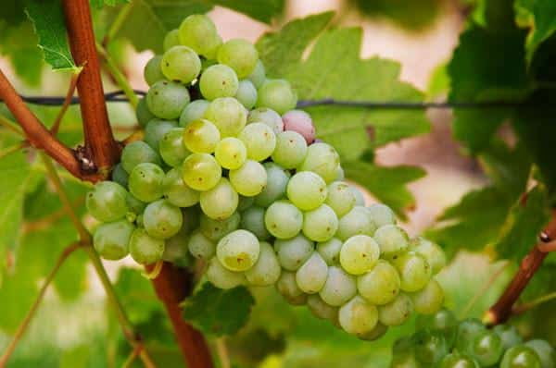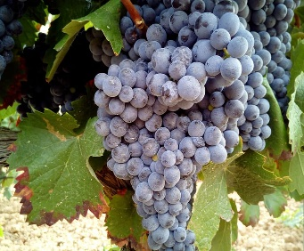

**Fig:-Black Grapes** **Fig:-Green Grapes**

**1.3 Production:-**

**Divine Winery Pvt. Ltd** has produced different types of wine according to the market demand. Mainly, they produce red and white wine.

**OBJECTIVES**

1. To gain creative, descriptive, analytical and explanatory understanding of wine production and the technology used.
2. To study the existing management system and technology of company.
3. To understand the application of instrumentation system in real field and to observe application of different types of electrical and electronics instruments
4. To be familiar with the various engineering aspects demanded by the company.
5. To learn the vital role of engineering in the company.
6. To observer the current system carefully and detect any fault in existing system if any.
7. To purpose solutions to boost the efficiency of the system.

**WINE MANUFACTURING PROCESS**

Wine manufacturing process includes following steps:-

## Harvest

## Crushing and Pressing

## Fermentation

## Clarification

## Aging and Bottling

## 3.1. Harvest:-

## Harvesting is the first step in the wine making process. The process of making wine requires the grapes that are harvested at a precise time, preferably when physiologically ripe. A combination of science and old-fashioned tasting usually go into determining when to harvest, with consultants, winemakers, vineyard managers, and proprietors all have their say. Harvesting can be done mechanically or by hand. Once the grapes arrive at the winery, reputable winemakers will sort the grape bunches, culling out rotten or under-ripe fruit before crushing.

## 3.2. Crushing and Pressing:-

Crushing the whole clusters of fresh ripe grapes is traditionally the next step in the wine making process. Today, mechanical crushers perform the time-honored tradition of stomping or trodding the grapes into what is commonly referred to as must. Mechanical pressing has also improved the quality and longevity of wine, while reducing the winemaker's need for preservatives. Having said all this, it is important to note that not all wine begins life in a crusher. Up until crushing and pressing the steps for making white wine and red wine are essentially the same. However, if a winemaker is to make white wine, he or she will quickly press the must after crushing in order to separate the juice from the skins, seeds, and solids. By doing so unwanted color (which comes from the skin of the grape, except the juice) and tannins cannot leach into the white wine. Essentially, white wine is allowed very little skin contact, while red wine is left in contact with its skins to garner color, flavor, and additional tannins during fermentation, which is the next step.

## 3.3. Fermentation:-

Fermentation is indeed the magic at play in the making of wine. If left to its own devices must or juice will begin fermenting naturally within 6-12 hours with the aid of wild yeasts in the air. In very clean, well-established wineries the natural fermentation is a welcome phenomenon. However, for a variety of reasons, many winemakers prefer to intervene at this stage by inoculating the natural must. Fermentation can require anywhere from ten days to a month or more. The resulting level of alcohol in a wine will vary from one locale to the next, due to the total sugar content of the must. An alcohol level of 10% in cool climates versus a high of 15% in warmer areas is considered normal. Sweet wine is produced when the fermentation process stops before all of the sugar has been converted into alcohol. This is usually a conscious, intentional decision on the part of the winemaker.

## 3.4. Clarification:-

Once fermentation is completed, clarification process begins. Winemakers have the option of racking or siphoning their wines from one tank or barrel to the next in the hope of leaving the precipitates and solids called pomace in the bottom of the fermenting tank. Filtering and fining may also be done at this stage. Filtration can be done with everything from a course filter that catches only large solids to a sterile filter pad that strips wine of all life. Fining occurs when substances are added to a wine to clarify them. Often, winemakers adds egg whites, clay, or other compounds to wine that will help precipitate dead yeast cells and other solids out of a wine. These substances adhere to the unwanted solids and force them to the bottom of the tank. The clarified wine is then racked into another vessel, where it is ready for bottling or further aging.

## 3.5. Aging and Bottling:-

The final stage of the wine making process involves the aging and bottling of wine. After clarification, the winemaker has the choice of bottling a wine immediately, which is the case for **Divine Winery Pvt. Ltd**. The choices and techniques employed in this final stage of the process are nearly endless, as are the end results. However, the common result in all cases is wine.

**Investment**

Any wine factory like **Divine Winery Pvt. Ltd** needs a huge investment since its establishment. Categories of how the huge investment is divided into following:-

**4.1. Raw Materials:-**

For the production of around 5000 liters of wine, grapes, yeasts, sugar etc. are required in large amount. The production of wine depends upon season. So, the cost of raw materials also depends upon it. Approximately, for production cost around 14-16 lakhs is needed for production of red wine and around 16-18 lakhs is needed for the production of white wine.

**4.2. Machineries:-**

Different mechanical along with electronic machines are required for the production of wine. Capping machine, Bowl Vibrator, Filling machine, Heater, Labeling machine, Reservoirs, Squeezers etc. requires an investment of around 7-10 crores.

**4.3. Production Costs:-**

An average bottle of red wine (750ml) cost around Rs.800 to the company while for the white wine (750 ml) it cost around Rs.850 which includes the price of bottle, labeling and packaging.

**4.4. Marketing:-**

The marketing cost varies from company to company. **Divine Winery Pvt. Ltd** invests heavily on marketing its products. Its advertisements are published in newspapers as well as in digital marketing. Approximately 4-6 lakhs is required for marketing.

**BLOCK DIAGRAM**

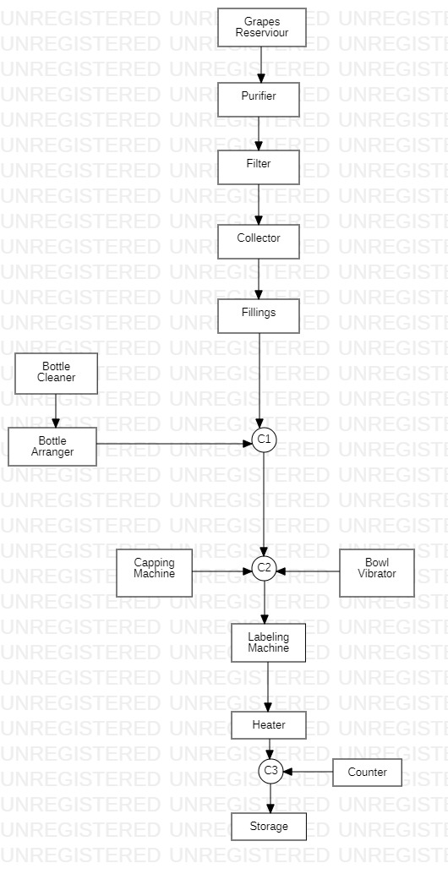

**Fig:-Production of Wine**

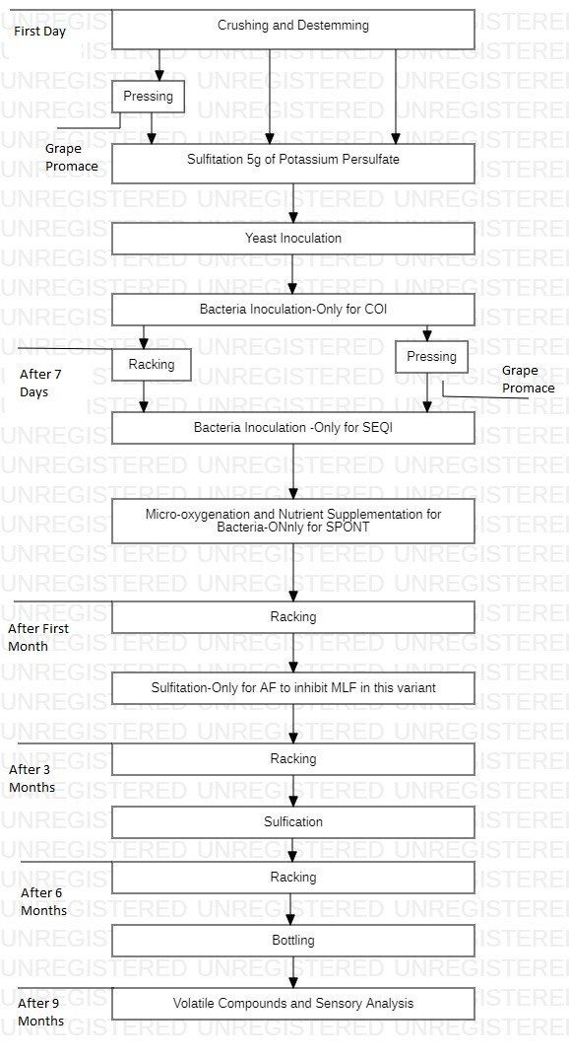

**Fig:-Production of Red and White wine**

**Grapes Reservoir:-**

A clean batch of 2-3 tons of grapes are stored in big reservoir of 6000 liters where they are fermented, squeezed and kept for around 4-5 months to obtain high quality wine. The finished product may contain some abnormalities so they are passed onto for purification process.

**Purifier:-**

A clean tank of around 2000 liters capacity is used where the product from the grapes reservoir is purified and the obtained product will be fresh and free of external toxic material. But the product may still contents of the grapes particle therefore it is send to filtering process onto a filter.

**Filter:-**

A tank with inbuilt filtering machine of capacity 2000 liters is used to obtain clean purified and filtered product.

**Collection:-**

Hence obtained product is cleaned, purified and filtered which is temporarily stored here. Later it is passed onto a filling machine.

**Bottle Cleaner:-**

A batch of glass bottle is passed here where the bottle is thoroughly cleaned and disinfected.

**Bottle Arranger:-**

The cleaned glass bottle is arranged in a line and is passed by a conveyer belt to the filling machine.

**Filling Machine:-**

A line of bottle is passed through the filling machine in which bottle is filled with the finished products and bottle moves onto another phase.

**Bowl Vibrator:-**

This machine is used to send bottle onto another machine one at a time to decrease crowding and increasing the efficiency of the production.

**Capping Machine:-**

The uncapped bottles are capped using the capping machine; one at a time and the sealed bottle is passed to another phase.

**Labeling Machine:-**

The sealed bottle is given a proper label in this phase and the label consists of proper name of the company, manufactured date, expiry date and the location.

**Heater:-**

This part of the wine production helps to attach the label firmly onto the bottles.

**Counter:-**

This section consists of computerized digital device that keeps in check the no. of bottle prepared.

**Storage:-**

The final product is then stored into a warm and damp place in cartoon boxes with proper label.

**Discussion and Conclusion**

A wine industry whose brand name is “Divine Wine and Beverage” is one of the pioneer companies of Nepal which manufactures 2 varieties of wines such as Red Wine and White Wine. The quality of wine is indicated by brand name although the company hasn’t been able to tap it in many numbers of cities of Kathmandu. It seems to be limited only in Kathmandu with one head office and next as its industry through which its exports it to varies cities of Nepal.

In Nepal number of wine manufacturing companies is increasing day by day but their quality is declining but Divine Wine and Beverage industry has been able to maintain its quality but also enhance its name and fame through its increasing quality but its price seems to be a bit high. It has been able to launch its best flavor in market since May 11, 2016 for which its essence is imported from western region of Nepal, India and China.

The technology used here is semi-automatic. The packaging system is totally manual and enhancing technology is explained above. It should give proper training to the staffs so that they can get their works done more easily and efficiently. Here number of workers seems to be a bit low still the company has been doing its best.

For more enhancing a good planning is needed in the near future and think on reducing the cost a bit because everybody may not be able to afford it.

**Photo Gallery**

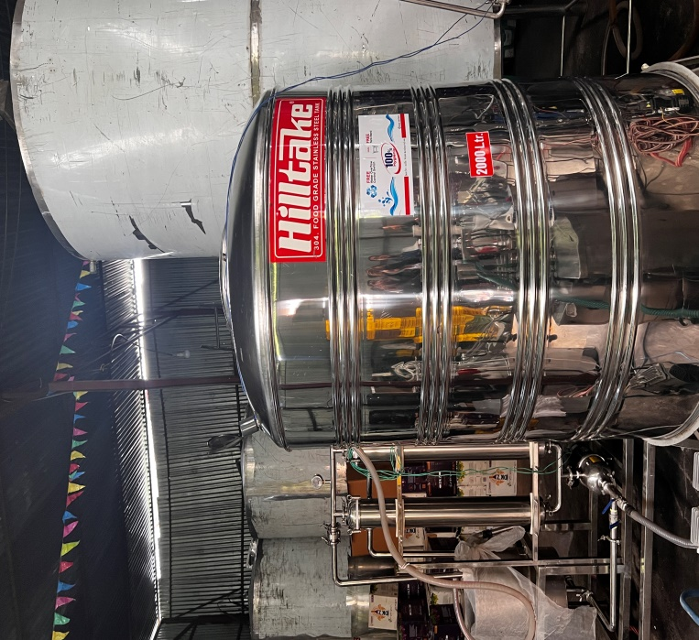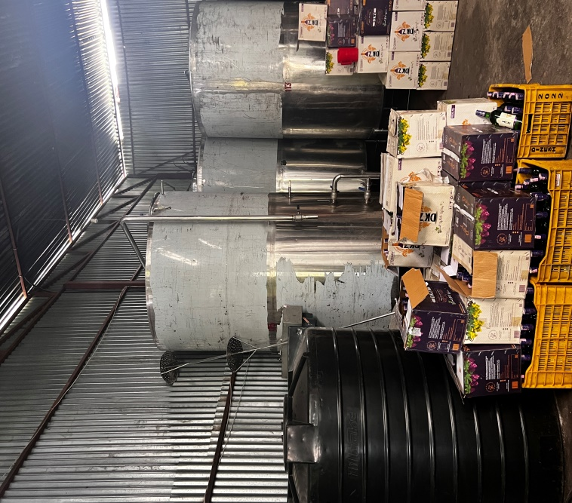

**Fig:- Grapes Reservoir Fig :- Purifier**

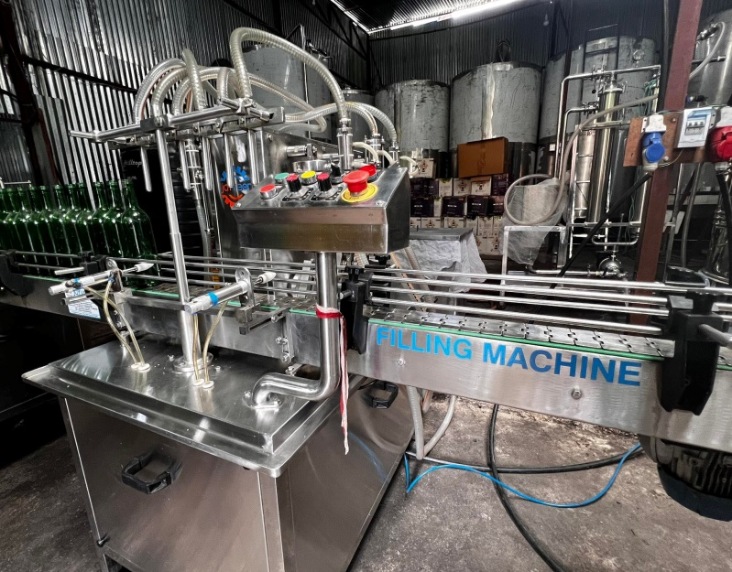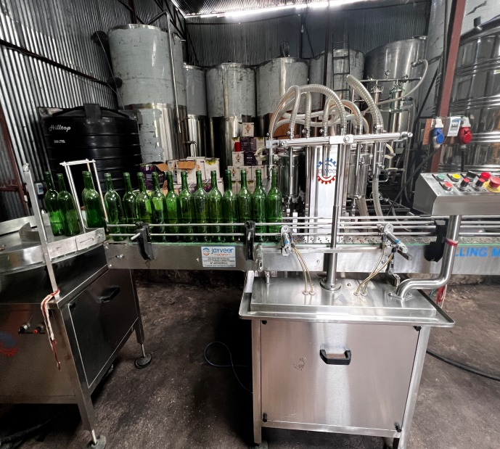

**Fig: -Bottle Arranger Fig:-Filing Machine**

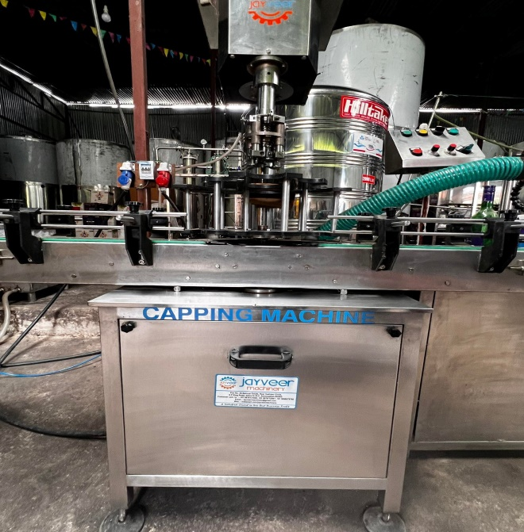 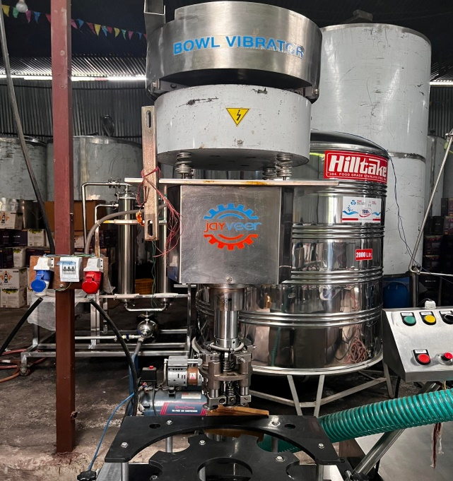

**Fig:- Capping Machine Fig:- Bowl Vibrator**

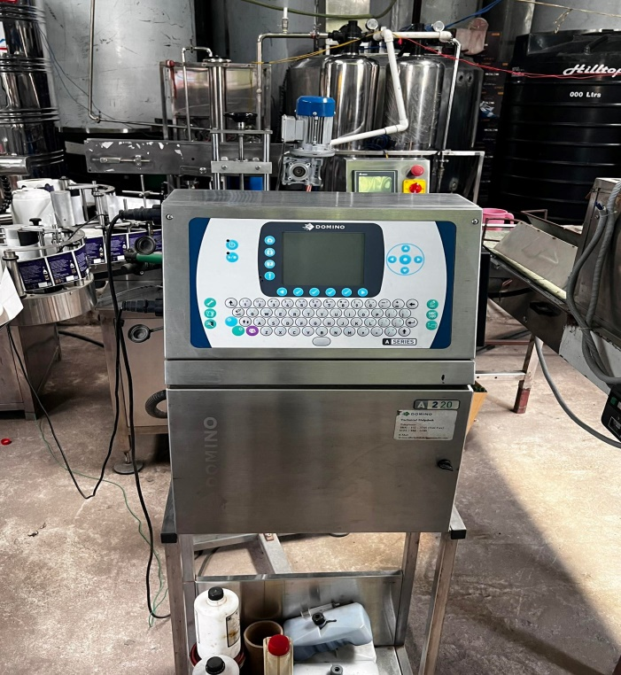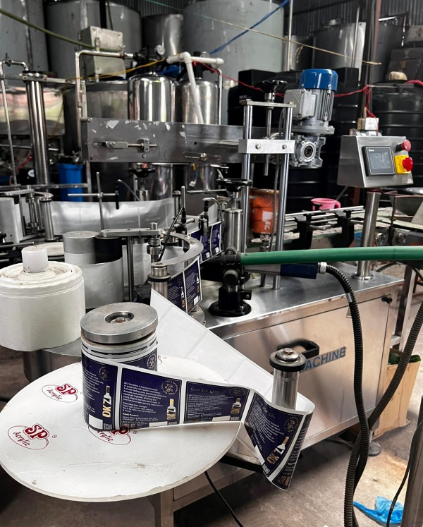

**Fig:- Bottle Labeling Fig:-Speed Machine**

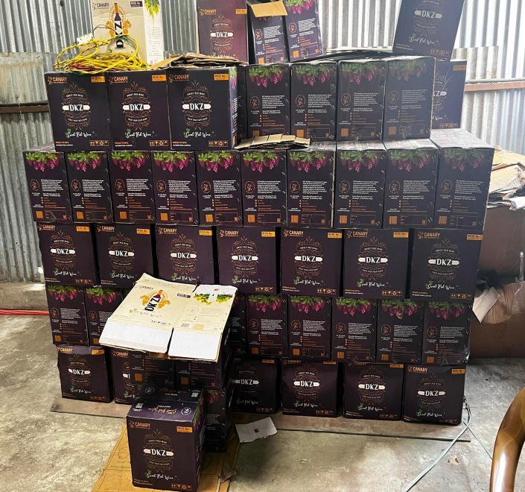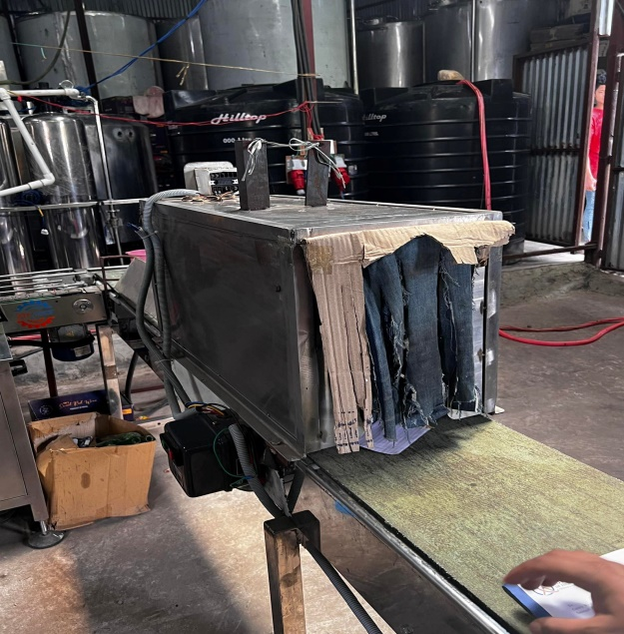

**Fig:- Heater Fig:-Final Product**

**References**

* <https://www.researchgate.net>